**DLD PROJECT PROPOSAL**

**GROUP MEMBERS:**

**Ahmed Aleem (20K-0169)**

**Ammar Siddiquie (20K-0177)**

**Agha Maarij Amir (20K-0160)**

**Saad Imran (20K-0189)**

**OBJECTIVE:**

The aim of the project is to develop a 4 input combination lock system, that allows the user to input the passcode,if the entered key is incorrect the alarm connected to the system is activated.

**Components Used:**

* XOR GATES
* NOR GATES
* LEDs
* RESISTORS
* DIP SWITCHES
* DIODES
* JUMPER WIRES
* PUSH SWITCH
* BATTERIES

**CIRCUIT DIAGRAM:**

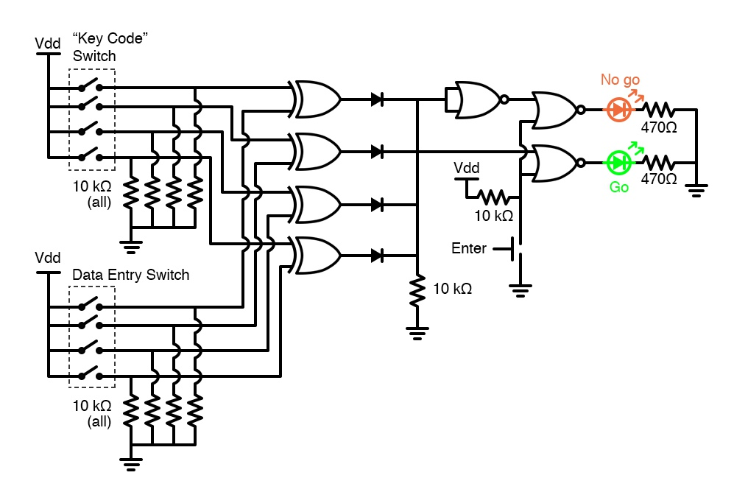

**BRIEF DESCRIPTION:**

The combination lock system is implemented using the xor gates and the universal nor gate. The xor gates are used as comparators to compare the input and the lock key, if the entered key is correct a green led is turned on, otherwise the alarm system is activated. This project covers the basics of digital logic, logic gates, implementation of combinational circuits and comparators.